SYSTEM NAME
System short description
Software Requirement Specification

Version 1.0
Revision 1.7

Last revised on March, 22 2006

Copy of Specification is owned by CUSTOMER and DEVELOPER. Any change in the specification must be coordinated between CUSTOMER and DEVELOPER and must be entered in History of specification changes in paragraph 6.

If you are reviewing a hard copy of this document then please note that this hard copy may not be the latest release of the document. The Project Manager maintains and controls the releases of this document. The Project Manager should be contacted for the latest release of this document.

CONTENTS
1. Purpose 3
1.1. Purpose of the Software Requirements Document 3
1.2. Scope 3
1.3. Definitions 4
1.4. Overview 4
1.5. Related documentation 5
2. Overall Description 6
2.1. Product Functionality/Features 6
2.2. User Characteristics 6
2.3. Constraints 6
3. Specific Requirements 7
3.1. Functional Requirements 7
3.2. Supplementary Requirements 7
4. Non-Functional Requirements 8
4.1. System Architectures 8
4.2. Security and Privacy Requirements 16
4.3. Performance Requirements 17
4.4. User Interface Requirements 17
4.5. System Documentation 18
4.6. Packaging Requirements 18
4.7. Acceptance Requirements 19
5. Models 20
5.1. Logical Model 20
5.2. Use Case Model 22
6. History of specification changes 27

Purpose

Purpose of the Software Requirements Document
The Software Requirement Specification (SRS) is a specification for a particular software product, program or a set of programs that performs certain functions in a specific environment.
The SRS should
- Correctly define all of the software requirements. A software requirement may exist because of the nature of the task to be solved or because of a special characteristic of the project.
- Not describe any design or implementation details. These should be described in the architectural design stage of the project.
- Not impose additional constraints on the software. These are properly specified in other documents such as a software quality assurance plan.
SRS limits the range of valid designs, but does not specify any particular design.
The current Software Requirement Specification presents a view of the functionality and specific features of the projected system. This document focuses on the capabilities needed by the target users of the CUSTOMER. This document also addresses a number of technical issues, including the most important technical decisions and system architectures.

Scope
This document defines the functional and business critical non-functional requirements to the System that an end User or the Business can perceive (such as presence or lack of a particular functional feature or the System break-down, outage, etc). Such requirements might, and normally do, imply some restrictions on the System design decisions. This almost always includes the selection of a target OS, Application Server, Development Platform, Production Environment and tools that can or should be used for the System development. Therefore, some basic architecture decisions are done on the stage of creating the System specification; hence they are the subject of being fixed in the SRS. This, however, does not imply that the SRS shall contain the comprehensive and in-depth System design – this activity should be considered as out of the scope of this document (SRS). Nor should the SRS define the Acceptance Testing procedure. This should be defined in the complimentary Acceptance Test Document [COREEE-CBSH-ATD] that is created later on in the course of the System development. The contents of the ATD derive straightforwardly from the Functional Requirements section of the SRS. ATD need not cover any additional requirements that are not defined explicitly within that section. Any additional acceptance tests that the CUSTOMER considers to be necessary shall be settled beforehand and shall be stated and mutually agreed with the DEVELOPER in a form of the Acceptance Test Document before the actual Acceptance Test phase of the project is started.

Definitions
This topic contains definitions for a variety of terms that arise in this and related documents.
UML Specific Definitions:
- Actor — someone or something outside the system or business that interacts with the system or business.
- Use case — a use case defines a set of use-case instances, where each instance is a sequence of actions performed by the system that yields an observable result of value to a particular actor. A use-case class contains main as well as alternate flows of events related to producing the 'observable result of value'
- Use-case diagram — a diagram that shows the relationships among actors and use cases within a system.
- Use-case instance — a sequence of actions performed by a system that yields an observable result of value to a particular actor.
- Use-case model — a model that describes a system’s functional requirements in terms of use-cases.

Domain Specific Definitions:
- Inventory – is a physical piece of metal (or pack of grain or coins) that is atomic (thus cannot be divided), measured in EA (each) and is stored within a Warehouse
- Warehouse – is a physical storage or a Vault that is a specially equipped premises that is used to store Inventory. Throughout this document the terms Warehouse, Vault and Site are used as synonyms.

Overview
For a fee, CBSH stores various types of precious metals for customers. CBSH tracks inventory per Customer by pieces and weight of a Commodity. A Customer is charged a storage fee on a frequency defined for the client based on the end of month closing balance of the commodity being stored. Storage fees are different depending upon the Commodity. The Customer is also charged separately for Withdrawing precious metals to cover handling fees, postage, and other miscellaneous charges.

The Safekeeping System (hereinafter the System) maintains balances for each Commodity held for each Customer (ChildCustomer). The user enters Transactions to deposit (Receive), withdraw (Ship), or transfer a commodity for a Customer as per their instructions. The client is to receive a confirmation known as a Safekeeping Advice for each of these actions.

At the end of each Statement Period the System generates a customer Statement of Holdings and a Transaction Statement.

Additionally, the System allows the User to request a daily Statement for any particular Customer. This Statement is identical to the regular customer statement except that it prints today’s opening balances, today’s activity, and today’s closing balance (or current balance if a day has not been closed). The daily Statement does not print Opening and Closing Balances for Commodities for which there was no activity.

Related documentation
- [COREEE-SRS] – Core Enterprise Edition SRS version 1.0
- [COREBASE-SRS] – Core.Base SRS version 3.4
- [COREBASE-AAD] – Core.Base AAD version 3.4
- [COREEE-CBSH-AAD] – Core Enterprise Edition Application Architecture Design

Overall Description

Product Functionality/Features
The System shall allow a User to manage Customers’ Inventory and Warehouse Receipt balances and to support the normal operation process of a Vault Worker. This includes:
- Providing support for Receiving (or depositing) of Inventory and Warehouse Receipts
- Providing support for Shipping (or withdrawal) of Inventory and Warehouse Receipts.
- Providing support for ownership tracking and transferring Inventory and Warehouse Receipts from one owner to another one.

User Characteristics
This section defines all users of the System. A user of the System can not only be a physical person who has an access to the System, but it can also be any external entity, such as a third party system, or an external process that initiates some certain activity.

- System User – a generic external entity that has an access to the System. This can be a human as well as any third party system including timer-based daemons.
- Vault Worker – an ordinary User of the System that has necessary access rights to perform all business Transactions except than performing the System installation and configuring including Warehouse and Customer maintenance, Location maintenance, Commodity Maintenance, etc.

Constraints
    - The System should not be considered as a 24 x 7 class system and therefore a special maintenance window need to be provided for normal System operation.

Specific Requirements

Functional Requirements
The functional requirements are represented in paragraph 5 as a Use-Case model.

Supplementary Requirements
    - All Reports should be displayed in PDF and MS Excel format.
    - The System shall use Crystal Reports Component to generate all reports.
    - Only Daily Accrued Income calculation has to be supported. The System need not support any other accrued calculation schemas (e.g. Monthly).
    - The System need not support the functionality of restricting particular Users to access only particular Warehouses. In other words there is no necessity in the binding a User to a Warehouse.
    - The System shall track the uniqueness of the combination of Commodity+Manfuacturer+Serial Number and shall give a warning to a User in case of duplication. However, the System shall allow a User to override the warning and enter a duplicated SN. Although internally that particular Bar shall be treated uniquely by means of an internal artificial key.

Non-Functional Requirements
Since the System is based upon the Core Enterprise Edition, please refer to the corresponding documents for details and guidelines.

System Architectures

Hardware and System Software Architecture and Computer Communication and Networking Architecture
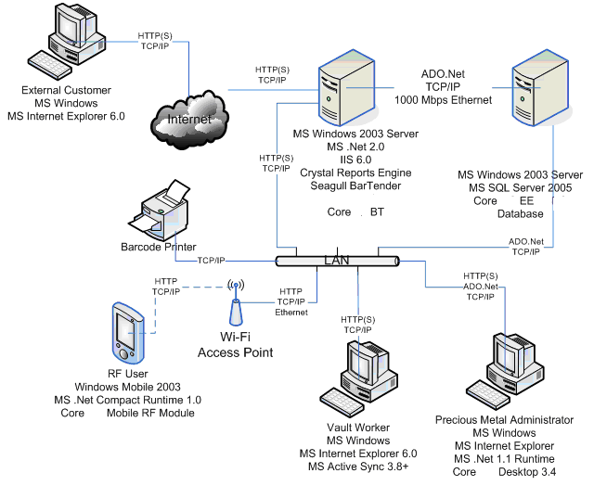
This joint diagram describes the necessary underlying software and hardware architecture together with their connectivity (please note that for the sake of brevity some software can be left out from the diagram, thus refer to the diagram description below for further details and more complete list of the software and hardware requirements).
The System physically consists of the following major parts:
- The Server-side part that contains the major part of business logic in a form of a web-based interface and Mobile RF Server-side part together with the database and the underlying system software. The Server-side part also communicates with the locally installed system software so as to provide such functionality as reporting (via Crystal Reports Engine) and Barcode Labels Printing (via Seagull BarTender software).
- The external client side, which is available for external Customers so as to allow them to keep track of their current Balance state and initiate defined set of Transactions.
The following subparagraphs define the necessary underlying hardware and software that has to be installed for the System to operate properly.
Web and Application Server:
- Hardware: Intel Xeon 2.8 GHz/1MB+ Cache, 800 MHz FSB, 4 GB RAM (or higher)
- Operating System: MS Windows 2003 Server SP1
- MS Internet Information Server 6.0
- MS .Net 2.0 Runtime
- Crystal Reports Engine v. 10
- Seagull BarTender Enterprise Edition 7.0
- CoreBT – independent Core BarTender connectivity module
Database Server:
- Hardware: Intel Xeon 2.8 GHz/1MB+ Cache, 800 MHz FSB, 4 GB RAM (or higher), EMC disks, 8GB disk space.
- Operating System: MS Windows 2003 SP1
- MS SQL Server 2000
Vault Worker Workstation:
- Operating System: MS Windows 2000 or XP
- MS Internet Explorer 6.0
- MS Active Sync 3.8+
External Customer Workstation:
- Operation System: MS Workstation 2000 or XP
- MS Internet Explorer 6.0

The Web and Application Server and the Database Server have to be connected with the dedicated 1000 Mbps Ethernet segment so as to isolate the local database-related traffic from the rest of the network activity. Although this is not a strict requirement, in the sense that the System can operate without that feature, but it might affect the overall network and the System performance. Please also note that, although it is certainly possible to deploy the Database on the same host that runs the Application Server, this approach, however, might lead to a poor performance result.

Application Software Architecture

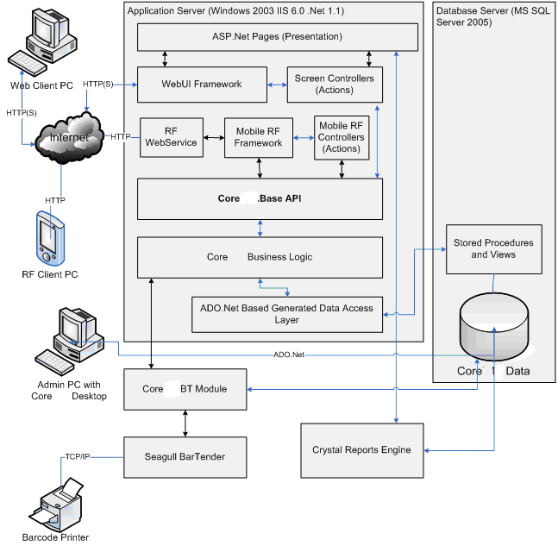
The System has clearly separated layered architecture so that every layer is responsible to a restricted set of functionality whether it is the Business Logic, Data Access Layer of any other glue layers. This approach not only simplifies the future support, as it is possible to single out a particular component or a layer and test, debug or study it in isolation, but it also simplifies the isolated testing approach that is used during the course of the development process. This means that possible bugs or malfunctions can easily be isolated and fixed.
There are following architectural layers that comprise the System:
- Database Layer – this layer contains the database schema and a set of views and storage procedures that perform basic stock-related operations. The decision to use storage procedures was made for performance reasons as some operations (especially stock and order validations) require several subsequent requests to data in the database, thus substantially increasing the amount of AppServer-to-DbServer traffic. To prevent this, a decision was made to keep the code that handles such cases as close to the data as possible, in other words – to use stored procedures.
- Data Access Layer (DAL) – To simplify the data access and to spare the programmers from direct coding the SQL statements, the generated DAL is created. The DAL allows basic Create-Update-Delete operations to be done without any hand coded SQL. This layer also provides the wrappers to the underlying stored procedures so as to isolate the underlying implementation of the latter and allowing the substitution of a storage procedure with a code in C# that is run within the AppServer process.
- Business Logic Layer (BL) – this layer encapsulates all major business logic operations and business rules check. Segregating Business logic into a separate layer allows substitute and modify it without changing other parts of the System.
- WebUI Framework – is a set of generic classes and interfaces that segregate the overall site navigation, event handling, controllers plug in, screen configuration and security. The framework makes it relatively easy to create new screens and modify existing ones by changing the set of internal XML-based configuration files that describes the layout and navigation of every screen.
- ASP.Net Pages (Presentation) – this is a set of standard ASP.Net pages that define the layout and serve as an entry URLs for the overall application. ASP.Net pages normally contain no logic at all, not even in the so-called code behind (although there are some specific exceptions) files. This leaves the pages maximal clear, since all controller code is located in the set of Actions, which makes it possible to test them in isolation.
- Client Side WebUI (JavaScript and Style sheets) – represented by a set of useful Java Scripts that provide validation logic, pop-up screens, Date Picker controls, etc. This is done to reduce the number of server requests hence to increase the overall System throughput and user-perceived responsiveness.
To glue the layers together the Spring.Net object container is used. This is an open source port from the corresponding Java project and provides the ability of pre-configuring the object graph, creating singletons and configuring them by means of the so-called IoC (Inversion of Control) paradigm that significantly simplifies the isolated testing process as virtually any object that sticks to that paradigm can be tested without the environment, thus providing reach possibilities for the object testing and substitution.

Federation Architecture
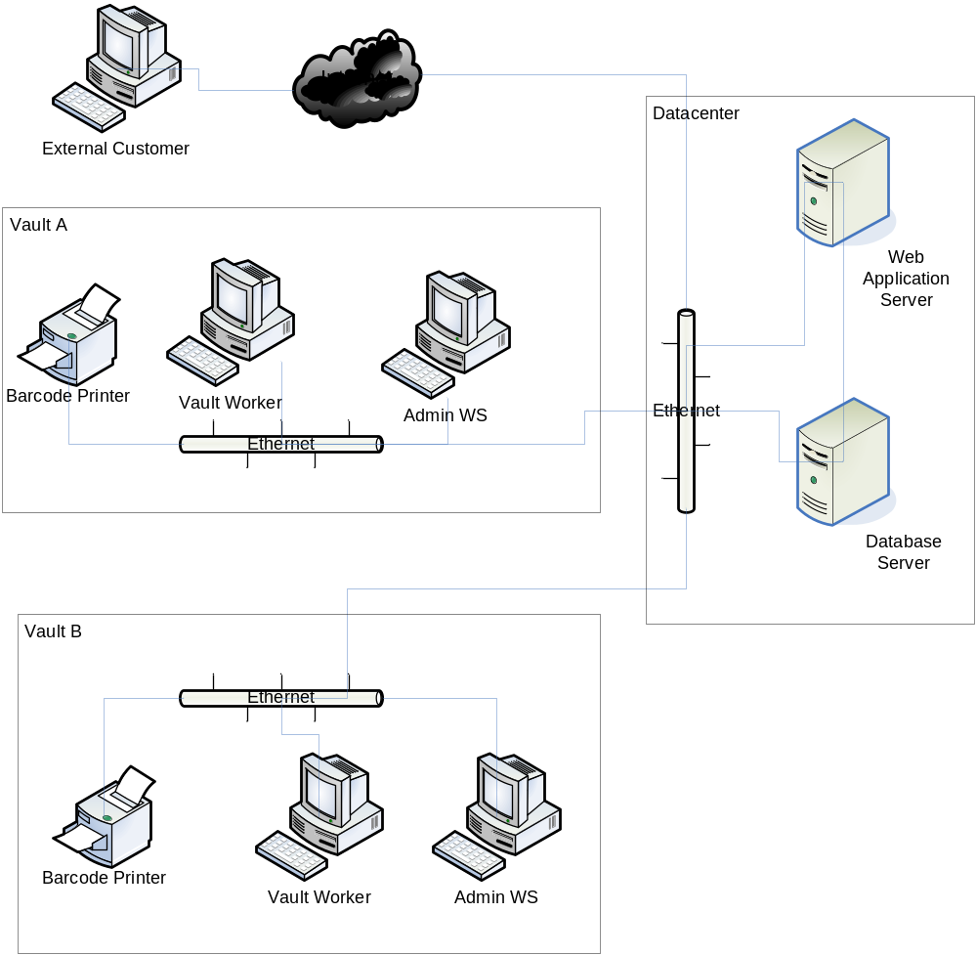
There are at least four physical locations where the System operates.
The core part of the System is located within the Datacenter. That might be a separate room where servers are installed.
There are also two physical Vaults (or Warehouses) that work with the System. These Vaults are in the same TCP/IP network and there are no proxy servers or firewalls installed between the Vaults and the Datacenter. The Printers and Workstations within the Vaults (as well as the Servers) have static IP addresses assigned to them.
The External Customer Workstation is a PC connected to the Internet. There are no special requirements for the External Customer Workstation to the Web Application Server connectivity. The essential is that the Server has to be reachable from the Internet via HTTP(S) protocol.

Database Architecture
For details about the Core Database please refer to the [COREEE-CBSH-AAD] and [COREBASE-AAD]

Integration Architecture
The System is supposed to be integrated into an Enterprise environment and has to provide integration points for feeding it with the Ownership Transfer instructions from CBOT and COMEX. The System has also to generate export of Account Entries to be fed to external General Ledger system and to generate necessary notifications in a form of a generic XML message so that they can later be used by third party fax or email software to be sent to an addressee.
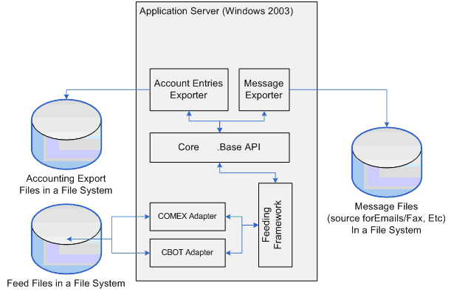
The diagram above shows the separation of concerns among the System and external systems that can work in collaboration therewith.
The format of messages and exports generated by the System and format of feed files fed into it is strictly defined in the corresponding section or an appendix of this document and mutually agreed by the CUSTOMER and the DEVELOPER. Please refer to the corresponding Supplementary Requirements section for more detailed requirements.

Development Tools Architecture
- The System Business/Web server part shall be developed using C#, Microsoft Visual Studio .Net 2005 and .Net Framework 2.0.
- The System Database part should be developed using T-SQL and MS SQL Server 20005.
- The System Reports should be developed using Crystal Reports Engine

Reliability
Please see Article 8 of the Software License Agreement for details.

Security and Privacy Requirements
    - All the System Users should enter the system by username and password.
    - Availability of the System UI controls should depend on logged-in User permissions.
    - The System shall support Role Based Security Model. I.e. if a User has a Privilege to perform Adjustment, he/she can do the operation on any Stock (unless restricted to a particular Site, see the requirement below). The Stock as well as any other entity object does not have a notion of an object-owner therefore allowing any User performing any operation restricted to his active Roles. In other words, no ACL is supported.
    - The System has predefined set of Privileges and Roles. This list of defined by the GUI Web Screens of the System. The means that every Screen except for look-up screens has two Privileges View and Modify. The final list of all Privileges shall include such pair for every Screen except from said look-ups.
    - The System shall provide the ability to setup User password expiration timeout via Configuration File and the System shall track that a password is expired and prevent a User from login without changing a password first.
    - The System need not provide the ability to waive some selected password from expiration. In other words every password shall expire after the same time period specified in the Configuration File.
    - The System need not provide the ability to force a User to change an assigned password upon the first login.
    - The System shall restrict External Customers to access their own balance information only or to their corresponding Child Customers’ balances.

Performance Requirements
    - The System (excluding RF Module part) shall conform to the following Performance requirements for defined hardware and software environment (see corresponding SRS section 4.1).

For ordinary daily Add, Update and Delete operations the Server shall send the last byte of a response within 3 seconds.

For online query and reporting with primary key parameter the Server shall send the last byte of a response within 5 seconds.

The database shall contain not more data entries for the major business entities listed below.
- Number of Customer <= 16000
- Average amount of different Customer’s Account Lines (per Commodity or WhsReceipt Type) <= 10
- Average (normally distributed) number of Business Transactions per day (such as Receiving, Shipping, Ownership Transfer, Creation/Redemption of a WhsReceipt) <= 200
    - The peak number of Business Transactions per day can reach up to 5000 at a month end. This has to be tested and the results of this test must be provided at the end of the project as a separate document.
    - The System need not withstand the aforementioned timings under the peak load.
    - There are no specific performance requirements for the parts of the System including Modules and 3rd party components that are not explicitly stated in the pervious paragraph.
    - The System shall provide the ability to change the period of time that sets up the part of historical closing balance data that are to be considered performance limited.
    - The Daily Accrual Process shall not take more than one hour to finish its job every business day within the aforementioned environment, providing that no other heavy-weight background process is running on the Application and Database Servers.

User Interface Requirements
    - The System web based UI should be optimized to be viewed in a maximized MS Internet Explorer 6.0 Web Browser window with the resolution set to 1024x768 pixels, one line Windows Task Bar located at the bottom of the screen, default Windows 2000 desktop theme (i.e. fonts, colors, pictograms).
    - The RF-Part of the System UI shall support PocketPC 2003, resolution 320x240 pixels and a color screen mode. No other screen modes and resolution has to be supported.
    - The System web based UI need not support any other browsers, including older versions of IE, any other screen modes or settings. Although the System will most likely work in slightly different environment, e.g. screen mode or resolution, this need not be guaranteed and need not be tested by the DEVELOPER, hence cannot be considered as a System Bug.

System Documentation
The System shall be bundled with the following documentation:
    - Core.Base API Documentation
    - System Installation and Administration Guide
    - User Guide
    - Online Help
    - RF Installation Guide
    - RF User Guide

Packaging Requirements
    - The System shall be delivered as a set of installers that performs the basis of the installation process and a comprehensive instruction that contains necessary steps and tips on how to install and tune the system in context of an enterprise. The System installation steps might also include running some initialization scripts, in this case such scripts shall be bundled together with the system and complimented with appropriate documentation for a member of a Maintenance Team to be able to go through this procedure.
    - The System Installer should be implemented using standard .NET installer tools.
    - A member of a Maintenance Team must ensure that he/she has all the necessary permissions to install and configure the System, that the Acceptance Testing and the Production Environment comply the necessary requirements defined either in this document or in any subsequent documents that comply the project lifecycle (such as AAD, Installation and Deployment Guide and Acceptance Test Document). The maintenance Team shall notify the DEVLOPER about any security limitations that the System might face beforehand and may not write it off to the DEVELOPER if some of the System parts cannot operate properly because of any security, network or underlying system software limitations (such as OS, DBMS and Application Servers including inappropriate versions and modifications (like Standard Edition vs. Enterprise Edition) thereof). Should this situation be the case (e.g. after successful functionality Acceptance Testing the System cannot be run in a production environment because of some environmental limitations), the DEVELOPER reserves a right to treat such situations as a technical support request which is a subject of separate estimations, shall be considered out of the scope of the project and shall not affect the fact of successful System acceptance.

Acceptance Requirements
    - Customer accepts the System on the terms of Acceptance Test, specified in Acceptance Testing Plan [COREEE-CBSH-ATD] that is to be developed and mutually agreed between CUSTOMER and DEVELOPER during the project course.

Models

Logical Model
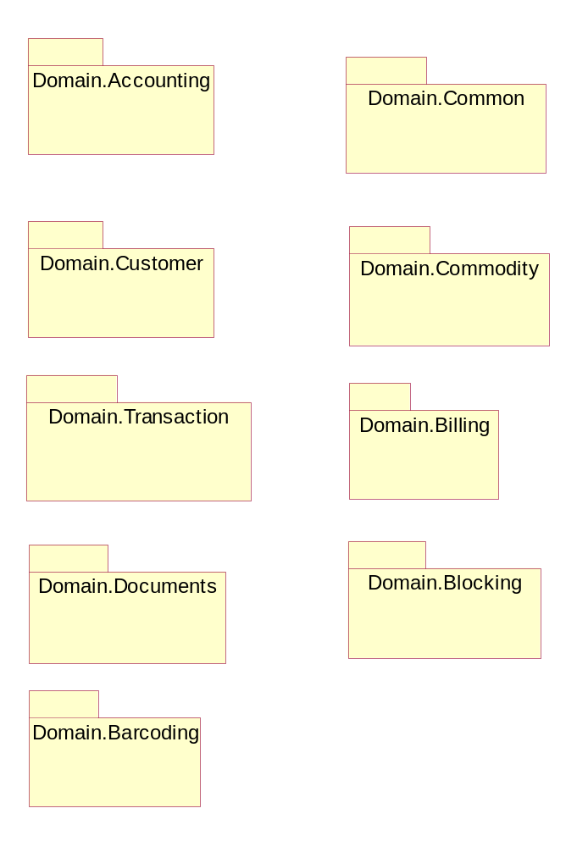

Common
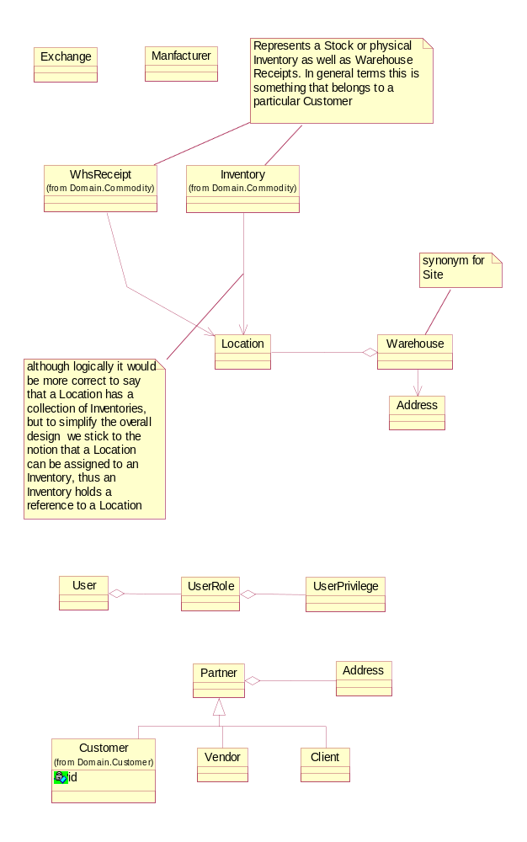

Use Case Model

Actors
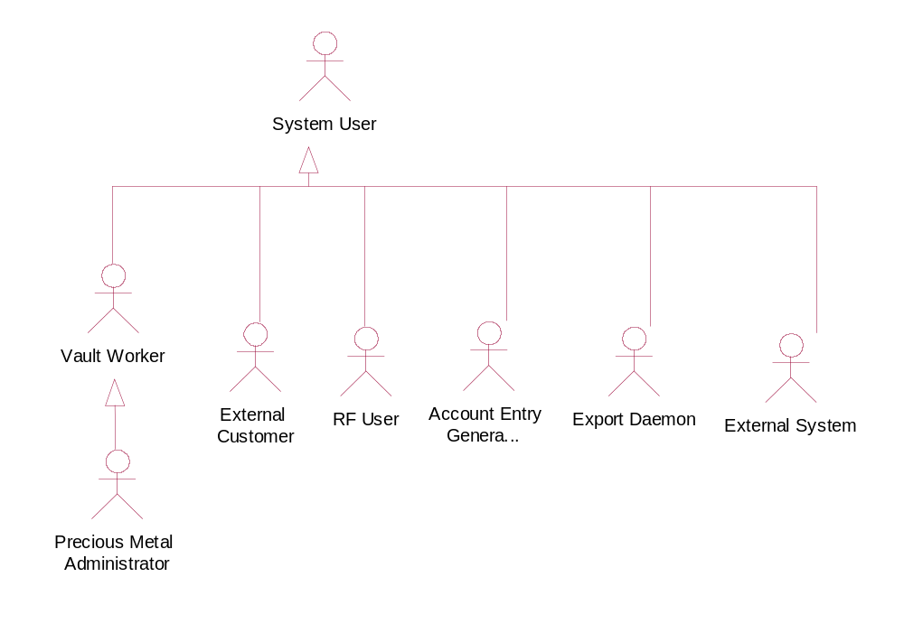

Use Cases
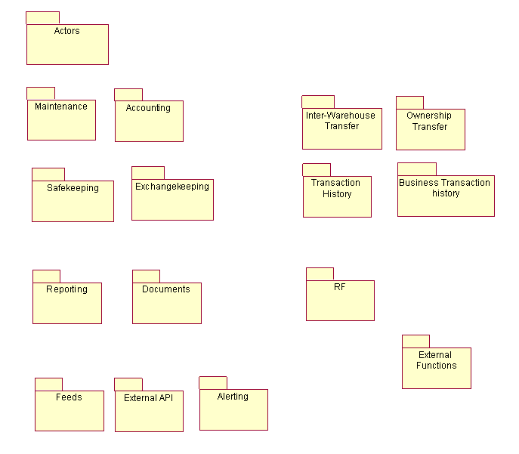

Accounting

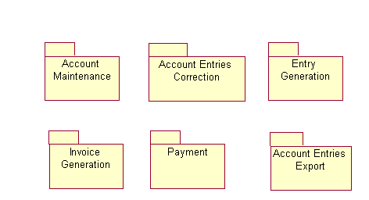

Account Entries Correction

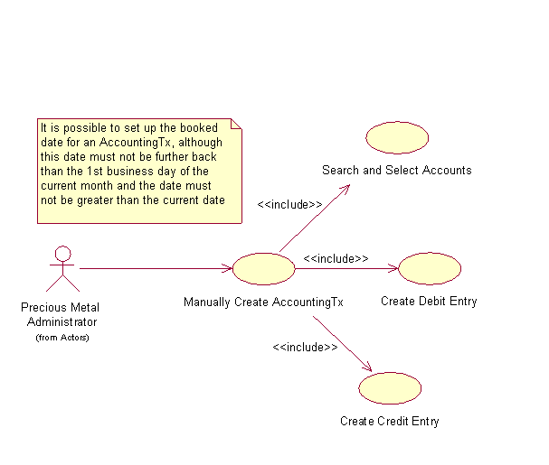

Account Entries Export

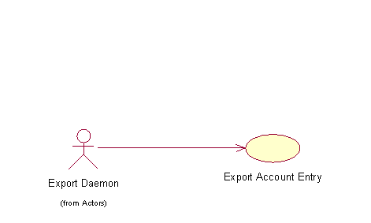

ExportAccountEntry
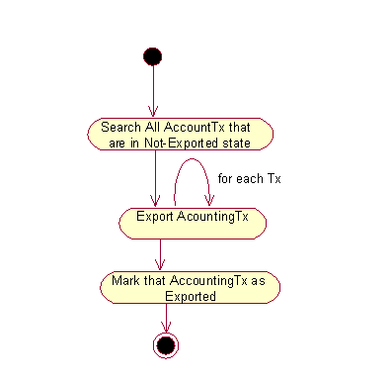

Account Maintenance

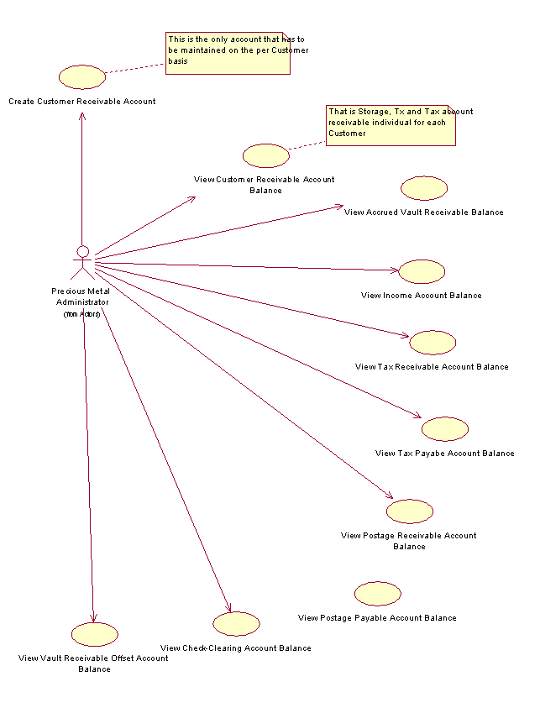

History of specification changes
This table should fix all Requirement changes after the SRS approval in order to avoid misunderstanding for project duration or required resources corrections.

# | Change Description | Initiator of change | Date of change | Change reason
1 | Migration to MS Visual Studio 2005 and .Net 2.0 | Customer | 03/22/2006 | Email from Customer of 2006-03-22

